Motion

Projectile Motion

Practise Book 1

Name: ________________

General Consolidation
Some Advanced Questions
Give all answers to 3sf
Ask me if you are stuck on any of these and there are answers provided, too.

1) A Punter on an NFL team kicks a football with velocity 35 m/s at an angle of 40* to the horizontal. The ball is caught 0.3m above from where it was kicked.
a) Determine the initial horizontal and vertical components of the velocity?
Ans: u_{v}= 22.5 m/s u_{h}= 26.8 m/s

b) Determine the total flight time of the ball?
Ans: 4.58s

c) What is the horizontal distance the ball has travelled?
Ans: 123m

2) A helicopter is ordered to drop a care package to soldiers on the front line. The helicopter is travelling at a horizontal velocity of 45m/s and the care package is dropped when the helicopter is 150 m above the ground.
a) How long does it take for the package to hit the ground?
Ans: 5.53 s

b) If air resistance is accounted for, what happens to the time travelled, Vertical acceleration and horizontal acceleration?
Ans: Time increased, Vertical acceleration unchanged, Horizontal increase

3) A sport scientist wants to figure out how high on average a baseball player can hit. A particular subject hits the ball at an initial velocity of 60m/s at an angle of 1.3* to the horizontal. There is a wall of height 1m, 15.0 m away from the subject. Wil the ball clear the wall?
15 = (60cos1.3)t
t = 0.250s
s_{v} = (60sin1.3)(0.250) – $\frac{1}{2}$(9.8)(0.250)² = 0.0340m

Ans: No the ball will not clear the net since s_{v}= 0.43 at that point < 1m

4) A cricketer hits a target with a ball that is 100m away from him and is 6m high. He hits the ball at 58* to the horizontal.
a) What velocity must the ball be at when coming off the bat?
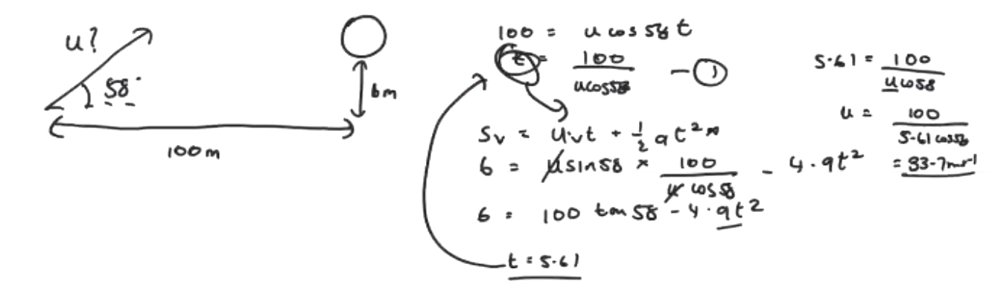
Ans: 33.7m/s

b) If he hits the same ball at 65* instead, with the same velocity will the ball hit the target? 